Ink

Every Month in SoHo, a Bit of Finnegan Lives
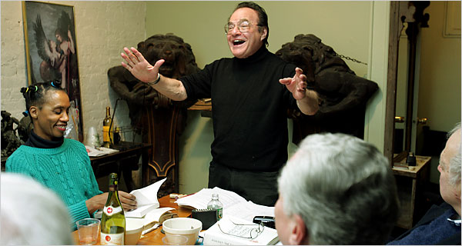
Michelle V. Agins/The New York Times
Murray J. Gross leads the “Finnegans Wake” meetings in his Spring Street apartment.
By LILY KOPPEL
Published: November 28, 2006
ON Thanksgiving eve, after 15 years of monthly meetings to read and discuss a page or so of “Finnegans Wake,” the Finnegans Wake Society of New York was only on Pages 303-5, with 324 to go. James Joyce’s novel could be the most difficult in English, with puns in 40 languages, including Esperanto and Volapük.
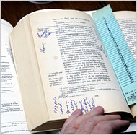
Michelle V. Agins/The New York Times
There is much waving of hands and citation of marked texts during the discussions.
Until three months ago the Wake Watchers, as the members call themselves, used to meet at the Gotham Book Mart in Midtown. The store has closed its doors for financial reasons, however, and so the group now convenes in the SoHo apartment of its leader, Murray J. Gross, 71, a retired lawyer known for his eye-rolling interpretations of sexual allusions.
The group’s gatherings are reminiscent of 1920s culture, when literary interests evolved from the apartment salon to specialty bookstores, like the Gotham. It was opened in 1920 by Frances Steloff, who challenged federal obscenity laws by insisting on selling Joyce’s earlier novel, “Ulysses,” when it was published in 1922. Miss Steloff was one of the original members of the James Joyce Society, and Joyce himself ordered books directly from Miss Steloff, according to finneganswake.org, the society’s Web site.
The group starts its monthly meetings by reading the passage aloud before discussion. Last week’s passage opened with the words, “As I was saying, while retorting thanks, you make me a reborn of the cards.” The passage closed with “Item, mizpah ends.”
As the group made its way through its textual critique, there was much crunching of potato chips and trail mix, and a prominent refrain during the discussion was, “Pass the wine!” Interpretations ranged far and wide, to subjects as varied as baseball, the death tarot card, the Gap and Allah.
Before the meeting started, Marilyn Apelson, a gray-haired teacher from Manhattan, who has been with the group since the beginning, was searching the row of rusted buzzers. “I can never remember where to ring,” she said. As it turned out, Mr. Gross’s apartment was under the name “James Joyce.”
Upstairs, 15 people gathered around a 20-foot-long wooden table, which fit snuggly in a room lined from floor to ceiling with bookshelves warped under their loads. There was a life-size wooden cutout of James Joyce close to one of Marcel Proust with an orchid boutonniere. (Their meeting famously fizzled.)
After the discussion, Judd Staley, 26, a high school teacher, accepted a Dunhill cigarette from a member many years his senior. New participants are encouraged to start any time, the novel having a circular plot structure. Beyond a $2 voluntary contribution there are no membership dues, other than a copy of “Finnegans Wake,” for a ticket to the novel’s dream world.
[]

